**Test Cell Start-Up Procedure**

1. Turn air handler to TEST
2. Turn ON the battery box switch
3. Check engine oil level (use 0w-16)
4. Check coolant level
5. Check fuel level and type
6. Verify fuel valves are on
7. Ensure chilled water valves are on
8. Check coolant level in radiator tower and intercooler reservoir
9. Inspect driveshaft, engine mounts and exhaust system. Verify everything is tight and connected.
10. Turn on Hartzel fan directed at exhaust side of engine.
11. ECM 4800 enable sensors and measure

**Scan Tool Hook-Up Procedure to Clear DTCs**

1. Test cell is shut down
2. iTest select OBD mode
3. Scan tool open toolbox, self-test, all CMDT
4. Clear all DTCs
5. iTest OBD mode off

**RPECS Start-Up Procedure**

1. Login
2. RPECS – Toyota Camry
3. M - monitor

**iTest and Vehicle Start-Up Procedure**

1. Put vehicle PRNDL lever in P position
2. Silverado transmission shifter in neutral (shifter has two positions. down is neutral, up is drive)
3. RPECS Gear = 4, TCC = Unlock, LPDA = .22
4. Launch iTest
5. Select starter and automatic
   1. Engine should start and idle; dyno spin to 300 rpm
   2. Allow the engine to idle for 2 minutes
6. Ramp dyno speed = 1000 rpm, pedal = 0
7. Shift Silverado trans to drive (pull shifter up)
8. Put vehicle PRNDL lever in D position
9. RPECS d (locks torque converter). Verify RPECS displays “Lock”
10. Ramp dyno and engine: dyno = 2000 rpm in 10 sec

pedal = 15 in 10 seconds

1. Vehicle PRNDL to S1
2. Verify engine is running properly (oil pressure, ECM lambda = 1.0, cyc avg torque is smooth)
3. Verify no check engine, ABS, etc DTC’s on dash. Clear codes if DTC’s are present.
4. Run for 5 minutes
5. Ramp pedal to 20.
6. Warm up until eng_Tcoolant = 80C and oil temp = 70C
7. Ramp dyno speed = 2200 rpm, pedal = 45

**Pre-Run Checks**

1. Verify engine is running
2. Verify oil pressure > 100 kpa
3. Verify fuel pressure ~ 60psi (490 kPa)
4. Set coolant temperature setpoint = 80 C
5. Set oil temperature setpoint = 70 C
6. Set intercooler temperature setpoint = 35 C
7. Get ambient HC/CO in iTest
   1. Unselect Heated Probe
   2. Select Ambient Probe
   3. Select Sample
   4. Wait until ambHC and ambCO stabilize
   5. Select Standby
   6. Unselect Ambient Probe
   7. Select Heated Probe
   8. Select Sample
8. Verify CAS screen is active & matching numbers on the iTest screen
9. iTest mapping display - verify temperature & stability criteria are correct.

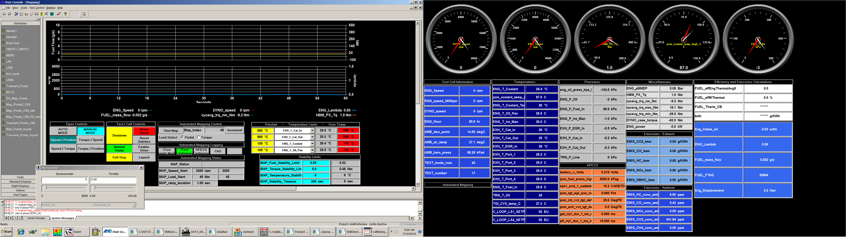

**Begin New Test**

1. Select **New Test**
   1. Change test info, date, etc.
   2. Continue
   3. Increment (new Test Number; run number reset to 0) or Continue (continue with previous Test and next run number)
2. Start each new test with a Common Mode Daily Check
   1. 1500 rpm 15% pedal until oil is 65 C minimum
   2. **Common mode is 2500 RPM & 30% throttle**
   3. Wait until Oil Temp is 80C & Water Temp is 90C
   4. Single mode log
   5. Ensure consistency with previous Common Mode runs
3. Begin mapping

**Engine Shut-Down Procedure**

1. Manual ramp down to dyno RPM = 1000, pedal = 0
2. Vehicle PRNDL to Park
3. RPECS TCC unlock, enter d
4. Shift Silverado trans to neutral (down)
5. Trans module to Park
6. Wait 60 seconds if engine is hot
7. Select iTest shutdown
8. Turn air handler to OFF
9. Turn both battery switches to OFF
10. Turn off ECM sensors: sys, disable sensors